**KADDI Onboarding Information Sheet**

**Physical Exam**

* Submit a physical form or written statement from your physician that you are in general good health and physically able to complete the internship
* A sample physician form is provided to you by KADDI if needed or requested by your physician (optional, not required)

**American Heart Association Basic Life Support (BLS)**

* It must be done through the American Heart Association
* It must not expire prior to the end of your internship program
* Please enroll online using this link <https://cpr.heart.org/en/cpr-courses-and-kits/healthcare-professional/basic-life-support-bls-training>
* You may choose the online blended course or the on-site course
* Click “Find a Class” at the top Left corner  
  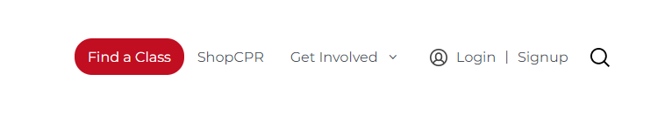
* Type in your zip code to search for classes around you. You can narrow your search in the Filter section and select BLS Provider. Sometimes facilities will have classes and it not be listed. So if nothing pulls up, try calling the site to see if they have any upcoming classes.

**ServSafe Manager Certification**

* If you do not already have the certification, you may enroll online at [www.ServSafe.com](http://www.ServSafe.com)
* Must take the ServSafe Manager Exam. KADDI recommends purchasing the ServSafe book and Online Exam with proctoring. Because you do not have a proctor access code, you cannot choose the access code option.
* The ServSafe book includes practice questions to prepare you for the exam.
* Course is 8-10 hours. Exam is 2 hours.
* You will have 2 months to complete the online course once started.
* Passing for the exam is 75% or higher.

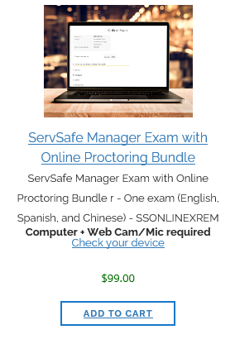

**Vaccines**

The following vaccines below are required & need to be submitted to the program. Submit an immunization record or titers.

* **MMR** (rubeola, mumps, rubella): 2 vaccines or serological testing to demonstrate immunity
* **Varicella**: 2 vaccines or serological testing to demonstrate immunity (a document stating you had chickenpox is not sufficient)
* **Hepatitis B**: documentation of immunization (series of three doses) or documentation of titer
* **TB skin test**: negative PPD every year. If there has been a positive PPD history: a chest x-ray within the last 12 months is required.
* **Pertussis**: Tdap required (must be within the last 10 years)
* **Influenza**: Vaccine for current season; accepted immunization date cannot be earlier than August 1 of any given year and must be completed prior to beginning your rotations.
* **COVID**: Must obtain full series before starting rotations.

***NOTE:*** *some facilities may require additional screenings such as more in-depth background check, fingerprinting, drug test, etc.*

**Verification Statements & Transcripts**

* An original DPD Verification Statement from an accredited didactic program in dietetics (after DPD graduation).
* You may email an electronically signed DPD Verification Statement to [KADDI@consultingdietitians.com](mailto:KADDI@consultingdietitians.com)
* Provide a copy of the official transcript with the highest earned degree posted on it

**Health Insurance**

* Submit a copy of your Health Insurance card to KADDI

**Auto Insurance and Driver’s License**

* You must have a valid Driver’s License & Auto Insurance if you will be driving during the internship experience